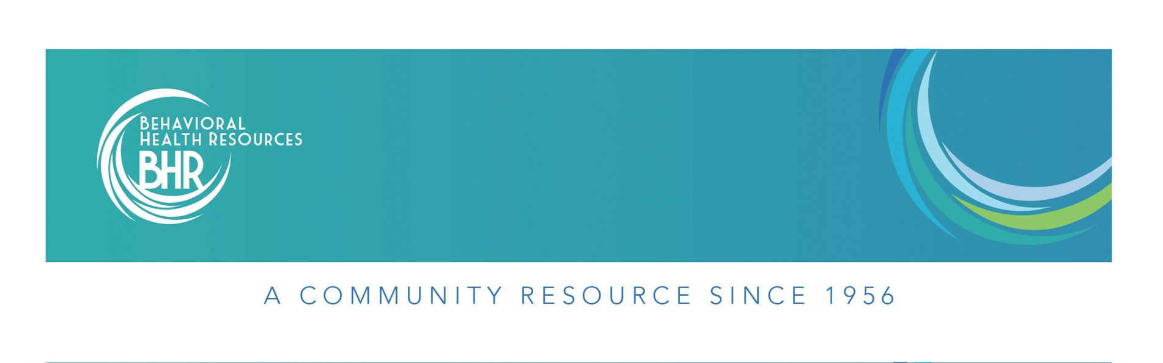 **QUALITY MANAGEMENT DEPARTMENT**

**New Journey’s Flow Sheet**

**Purpose**

This purpose of this protocol is to clearly define the process for accepting new clients into the New Journey’s program within BHR. Any specific questions related to New Journey’s clients and the admission process should be directed to the appropriate New Journey’s supervisor.

**Protocol**

**External Referrals**

1. New Journeys staff receive a request for information or referral for an individual **not currently** enrolled in services at BHR.
2. New Journeys staff will request OS open a chart for potential client in AVATAR under the New Journeys-Request for Services (NJ-RFS) program.
3. OS staff will open the RFS episode by completing the following:
   1. Checking Provider One for Medicaid coverage
   2. Consumer First Contact Service form
   3. Admission form
   4. **Please note**: OS will enter an Admission Diagnosis of R69 for the same date and time Episode was opened (Type of Diagnosis = Admission, Assessment Type = Admission).
4. New Journeys staff will obtain funding information for the potential client
   1. New Journeys staff will ask client/guardian if client has additional funding
      1. If client has private insurance, make a copy of front and back of insurance card and submit for scanning
   2. New Journey’s staff will email all funding information to the BHR Financial Department at: Accounts Receivable e-mail ([accountsreceivable@bhr.org](mailto:accountsreceivable@bhr.org)).
5. New Journeys staff will bill to, and document contact with, client and collaterals in AVATAR in the NJ-RFS Episode, using the following codes:
   1. SAC (H0023HW) “Engagement + Outreach” for face-to-face service
   2. SAC (H0023HWGQ) “Engagement + Outreach –Phone” for phone service
   3. Specify in each note that you are working on assessment and engagement
   4. For related travel, staff will use SAC (735) “Travel”
6. If New Journeys staff decides client is **not** appropriate for New Journeys during the engagement/screening process:
   1. New Journey’s staff will complete Discharge Summary form
   2. After finalizing Discharge Summary form, New Journey’s supervisor will complete Discharge form – Type of Discharge is “OP – Terminated by Facility”, Note is “Not appropriate for New Journeys – Referred to _________”
   3. Clients with Medicaid coverage or those who wish to pay out of pocket should be referred to BHR for walk-in intake assessment, or other appropriate community partner (ex. WISe).
   4. Clients with private insurance should be referred to provider who accepts client’s funding source
7. If New Journeys staff decides client might be appropriate for New Journeys during the engagement/screening process, and the client agrees to complete Intake:
   1. New Journeys staff will provide OS with information about when the Intake Assessment can be completed.
   2. OS will make an appointment in the Avatar Scheduling Calendar.
8. If the client does show up for their scheduled intake:
   1. New Journeys staff will enter a Program Transfer from NJ-RFS to the New Journeys program.
   2. New Journeys staff will complete BHR paperwork, BHR Intake Assessment including Diagnosis (Type of Diagnosis = Update, Assessment Type = At Admission), and New Journeys specific assessments with client. The Intake should be billed to and documented in the New Journeys episode using the following codes:
      1. Full/completed intake: SAC (90791) “Diagnostic Evaluation-No Medical”
      2. Unfinished intake (part 1) SAC (9079153) “Diag Eval-Not Completed”
      3. Unfinished intake (part 2): SAC (9079152) “Diag Eval –Abrv, Partl or Update”
   3. New Journeys staff will complete the BHR Authorization form.
      1. For clients who will be admitted to New Journeys, Authorization Type is New Journeys. Duration of authorization is 12 months.
   4. New Journeys staff will submit all BHR paperwork to OS for processing
   5. Once all documentation, including intake, is submitted for clients who will be served in New Journeys, New Journeys staff can begin using all approved Service Activity Codes.
   6. All services for admitted New Journeys clients should be billed to and documented in the New Journeys episode.
9. If the client does **not** show up for their intake appointment:
   1. New Journeys staff will call client or hospital and explain they missed their scheduled appointment and **either** inform the client of BHR’s walk-in intake hours **or** attempt to schedule a new intake.
      1. Bill phone service as SAC (H0023HWGQ) “Engagement + Outreach –Phone”
   2. New Journeys staff will complete Discharge Summary form
   3. After finalizing Discharge Summary form, New Journey’s supervisor will complete Discharge form – Type of Discharge is “OP – Terminated by Facility”, Note is “Client did not show for Intake”

**Internal Referrals**

1. The New Journeys Supervisor should consult with the BHR staff requesting admission into New Journeys to confirm that the client meets eligibility for screening.
2. If it is agreed that the client meets eligibility criteria, and the client is agreeable to completing a screening, a NJ-RFS episode should be opened in Avatar.
3. **Please Note**: If a client is being referred from intake and has **not** yet started services with New Journeys and is eligible for New Journeys a NJ-RFS does **not** need to be opened, screening will be completed under the OP episode. Each potential New Journeys client that is being referred internally should be individually evaluated as to whether or not a NJ-RFS episode should be opened. As a general rule of thumb: If the client clearly meets criteria for New Journeys, and is agreeable to participate in the program, the client can be immediately enrolled in the New Journeys program – thus bypassing the NJ-RFS episode.
4. If more time is needed to determine client eligibility, and client engagement and outreach, a NJ-RFS episode should be opened. If this is done, a new Consumer First Contact Service form must also be created.
5. If New Journeys staff meets with client and/or collaterals **without** the regular Attending Practitioner, these services should be billed to, and documented under, the new NJ-RFS episode.
6. If New Journeys staff meets with client and/or collaterals **with** Attending Practitioner, bill to and document in the new NJ-RFS episode using the following code:
   1. SAC (22) “Secondary Practitioner”
7. If client is **not** appropriate for New Journeys, this should be documented in client chart under the new NJ-RFS episode. Once documented, and all parties notified, the NJ-RFS episode may be closed.
8. If the New Journeys staff decides client will be appropriate for New Journeys during the engagement/screening process, and the client agrees to engage in the New Journeys program:
   1. New Journeys Supervisor will enter a Program Transfer to New Journeys program.
   2. New Journeys Supervisor will ensure that a new BHR Authorization form is completed that states the new program for the client. Authorization Type is “New Journeys”. Duration of authorization is 12 months.
9. Once all documentation is submitted for clients who will be served in New Journeys, New Journeys staff can begin using all approved Service Activity Codes.
10. All services for admitted New Journeys clients should be billed to and documented in the New Journeys episode.
11. **Please Note:** For internal clients moving into the New Journeys program, the New Journeys Supervisor must evaluate the current intake assessment to determine if new intake assessment is required. As a general rule, intake assessments are valid for one (1) for program transfers. If the intake assessment is older than one (1) year, it is generally best practice to complete a new intake assessment. The New Journeys Program Supervisor will be responsible to evaluating the intake assessment and making this determination.